Suggested Section Report Format

PART A - SECTION SUMMARY

A.1 Executive Summary – (Please follow the format given below)

- Section Executive Committee Member List :
Chair: Tsutomu SASAO
Vice-Chair: "Tadashi SUETSUGU"
Secretary: Shoichi KUBODERA
Treasurer: Masahito SHOYAMA
Past Chair: Tatsuo OKADA
Membership Development Committee Chair: Kenji WATANABE
Professional Activities Committee Chair: Yuji OKI
Student Activities Committee Chair: Sunao KATSUKI
Chapter Promotion Committee Chair: Hiroaki NISHINO
Nomination Committee Chair: Tamotsu NINOMIYA
- Section Highlights
The membership of Fukuoka Section continuously increased. Total active membership of Fukuoka Section was 793 at Jun 2011. It is the highest record of our history.
- Major Events (International, National)
Fukuoka Section is one of sponsors of Joint Conference of Electrical and Electronics Engineers in Kyushu. This year, number of presented papers was 614. IEEE Fukuoka Section also sponsored International Session in this conference.
- Major Chapter Activities
- Major Student and Affinity Group Activities
- Awards
As the special event of Student Activities in the Section, the Excellent Student Award has been established since 2001. Last year, we had 33 applicants of students younger than 35 years old, and 11 recipients were elected through evaluating their published papers.

A.2 Financial Report – (Please follow the format given below)

- Summary (as per submitted L50)
- Any other financial activities

PART B - ORGANIZATIONAL ACTIVITIES

B.1 Membership Development Activities

- Total number of active members in the past 3 years.
2009. Jun: 713
2010. Jun: 767
2011. Jun: 793
- Summary and evidence of work done to improve the value of membership, which leads to retention and growth of members

B.2 Chapter Activities

- Total number of Chapters in the Section: 7
- Number of Chapters formed in the current year: 2
- Number of Active Chapters (Chapters who have reported required number of meetings during the year): 7
- Summary of Chapter activities chapter wise with attachment table / information

B.3 Professional and Continuing Education Activities

Summary of continuing Educational activities including conferences, technical activities, training courses, and distinguished lecture programs with attachment table / information

B.4 Students Activities

- Total number of Student branches in the Section: 1
- Number of Student branches formed in the current year: 0
- Section level student activities (student congress, paper and other contests, awards etc)
- Number of Active Student branches (Student branches who have reported required number of meetings during the year): 1
- Summary of Student branch activities student branch wise with attachment table / information

B.5 Affinity Group Activities

- GOLD
- WIE
- Life Member

B.6 Awards & Recognition Activities

- Award constituted by the section:
2011 Excellent Student Award
- Award(s) received from R10
- Award(s) received from IEEE HQ

B.7 Communication Activities (Newsletter, Home Page, E-mail etc.)

- Newsletter (name and number of issues in the year)
- Home Page of the section (give the URL and frequency which it is updated)
http://www.ieee-jp.org/section/fukuoka/index.php
- Other means of contacts with section members

B.8 Community Activities

B.9 Other Organizational Activities

PART C - OTHERS

C.1 Relationship with National Societies
Fukuoka Section participates Organization of JCEEE Kyushu (Organization of Joint Conference of Electrical and Electronics Engineers in Kyushu) from 2006. Fukuoka Section co-sponsors annual conference of JCEEE Kyushu (Joint Conference of Electrical and Electronics Engineers in Kyushu).
We make continuous efforts to collaborate with other domestic societies and other sections to increase the technical activities.
C.2 Special Events

C.3 Problems to be Anticipated

C.4 Best Practices of your section (which you would like share with other
sections for the benefits of members)

PART D - GOALS AND PLANS
D.1 Continuation of Project/Activity in Progress and Their Implementation
Plans
D.2 Goals and Future Plans
ANNEX

Table 1. Membership Development of IEEE Fukuoka Section in 2006 - 2011.

Fig.1. Movement of the Number of Membership in IEEE Fukuoka Section.

Table 2. List of Technical Lecture Meetings and Symposia held in 2011.

(1) Meeting Date: 02/04/2011, Category: Technical
Attendance: Members: 3, Guests: 12
Title of Meeting Professional Lecture for Translational Research between Lasers and
Life-Sciences

(2) Meeting Date: 02/10/2011, Category: Technical
Attendance: Members: 24, Guests: 80
Title of Meeting: Power Electronics Symposium sponsored by Nagasaki University
--- Power Distribution Systems expecting the World-Wide Use of SiC Devices ---

(3) Meeting Date: 06/14/2011, Category: Technical
Attendance: Members: 2, Guests: 19
Title of Meeting: Electric Power System and Power Education in Mongol

(4) Meeting Date: 06/21/2011, Category: Technical
Attendance: Members:, Guests:
Title of Meeting: The 25th extension lecture of Energy and Environment Technology

(5) Meeting Date: 11/24/2011, Category: Technical
Attendance: Members:, Guests:
Title of Meeting: The 27th Kyushu University Energy & Environment Engineering Course
Japanese-Mongolian Joint Symposium
─The Current Status and Future Movement of Smart Grid─

(6) Meeting Date: 12/26/2011, Category: Technical
Attendance: Members:, Guests:
Title of Meeting: The 28th Kyushu University Energy& Environment Engineering Course
─Korea-Japan Smart Grid Symposium─

Table 3. Finance Report for the year ending 31 December, 2010

RECEIPTS
Balance beginning of the year 1682497.
Rebate from IEEE Headquarter 430681.
Section Assessment from IEEE Headquarter 1136727.
Support for Section from Japan Council 200000.
Interest 539.
Total ￥3450894.

EXPENSES
Lecture & Social Events 82970
Executive Meetings (Travel) 60300
Section Congress (Travel Reimbursement) 0
Web Site Maintenance 20000
Support to Japan Council 1136202
Expense for Student Award 253379
Chapter Formation Support 0
Chapter Rebate to Chapters 92656
Support to Student Branch 0
JCEEE allowance -91000
Other Management & General Expenses 107480
Total ￥1661987

SURPLUS ￥1788907
Poster of Excellent Student Award 2011


The 64th Joint Conference on Electrical and Electronics Engineers in Kyushu Web Site
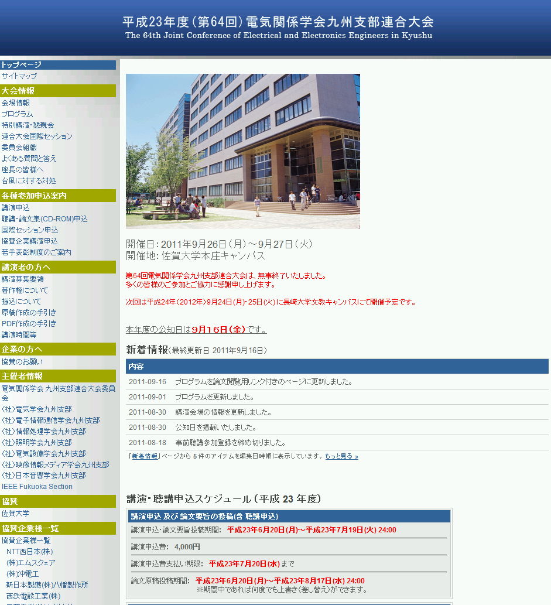
Fukuoka Section Web Site
