Region 10 Victorian Section Report 2017

PART A - SECTION SUMMARY

A.1 Executive Summary
Section Executive Committee Member List
Chair Eddie Custovic, Vice Chair Golnar Khomami Secretary Nishad Mendis
Treasurer Enn Vinnal Assistant treasurer Nalika Dona

Section Highlights
During 2017, POCO and sections congress were held in Sydney. However, the IEEE world president and her entourage visited Victoria and many events were held there, including two industry liason visits. Victorian section had a considerable input into organizing and formulating these events. ANZCON was also held in Sydney.

Major Events (International, National)
Clearly POCO and Sections congress come under the banner of international events and these events and associated visits to Victoria were successfully carried out. As well IEEE standards Association ran separate 3 hr workshops in Melbourne for academia and industry. As a result IEEE SA have identifies Melbourne as hot spot for standards and wish to drive more standards activity through Melbourne in 2018.

Major Chapter Activities
During the year, many technical meetings were held and some social functions for liason purposes were run. Apart from assisting with POCO and sections congress, a one day symposium was run on energy harvesting. This covered solar, wind vibration energy harvesting and even bee wing energy harvesting.

Major Student and Affinity Group Activities
Students from Victorian universities organized many events which promoted IEEE activities and generally increased student awareness of the IEEE activities.

Awards
Awards were of an internal nature. One special award was to the retiring treasurer Enn Vinnal who had provided many years of exemplary service.

A.2 Financial Report

 | 2017  ($) | 2016  ($) | 2017 - 2016 Change ($) | 2017 / 2016  Change (%)
Expenditure (ex GST) | 90,103 | 61,339 | 28,764 | 47 %
Revenue (ex GST | 75,046 | 54,564 | 20,482 | 38 %
Profit / Loss | -15,057 | -6,775 | -8,282 | -122 %
HQ Rebate | 17,545 | 17,248 | 297 | 2 %
Cash in the bank | 159,004 | 176,957 | -17,915 | -10 %
Net assets | 160,168 | 177,698 | -17,530 | -10 %

Summary is as above The L50 will be submitted in due course.
One point about financial activities was a charge for the Energy Harvesting Seminar. Due to charging
for this one day event, costs for the event were essentially covered by registration charge.

PART B - ORGANIZATIONAL ACTIVITIES

B.1 Membership Development Activities

Total number of active members in 2015 was 2006, 2017. Was 2113 and 2109. This is a 25% rise from 2008.
The improvement in membership is due to a steady rise in interesting IEEE activities well publicised to improve the value of membership, and leads to new members

B.2 Chapter Activities

Total number of Chapters in the Section is 20.
Number of Chapters formed in the current year is one. Industry Applications.
Number of active Chapters is 18.
Summary of Chapter activities. There were 88 reported events. The SSIT chapter was the leader with 11 events followed by Computer society with 9 events and SMC chapter with 7 events.

B.3 Professional and Continuing Education Activities

The main continuing Educational activities was the symposium on energy harvesting followed by several DL presentations on diverse but relevant topics.

B.4 Students Activities

Total number of Student Branches in the Section is six, Melbourne, Monash, RMIT, Swinburne, Victoria and Deakin Universities.
Number of Student Branches formed in the current year is nil.
Total student activities was 54, avery good number. A Melbourne Uni student Maryam Fanaeepour won the IEEE AC prize for best student paper.
Number of active Student Branches (Student Branches who have reported required number of meetings during the year) All sdent branches are active to my knowledge.
As above, total student activities numbered 54.

B.5 Affinity Group Activities

Young Professionals (YP), Women In Engineering (WIE) and Life Members all ran activities in 2017. WIE was the most active with a strong committee of dedicated women running many events.

B.6 Awards & Recognition Activities

Awardw constituted by the Section were internal for exemplary service to members and students.
Support was given to CAS society to present in Malaysia to enhance co-operation between Vic. Section and Malaysia. This was done by Alan Harvey

B.7 Communication Activities (Newsletter, Home Page, E-mail etc.)

A single Uplink newsletter was sent out in 2017. The Home Page of the Section http://www.ieeevic.org/ also gives details of events and is updated weekly in normal circumstances.
Contact is made with Section members through an IEEE Vic. Facebook page.

B.8 Industry Relations

Membership has increased 25% over the last 8 or so years. We believe that a strong events profile publicized to members and students has driven this growth. Activities with industrial members are encouraged and industry seminars publicizing our activities have been run.

B.9 Humanitarian Technology Activities

In this area the SSIRT chapter has run many activities. These activities have been run in different states of Australia.

B.10 Community Activities

- IEEE Social activities include IEEE day and our presence at job seminars.

PART C - OTHERS

C.1 Special Events

Main special events apart from POCO and sections congress were DL presentations and a one day symposium on energy harvesting. Funding secured from the IEEE allowed visits to Malaysia and presentation of lectures there.

C.2 Relationship with National and International Societies and Non-Government Organizations (NGO)

A formal agreement was signed following Sections Congress between IEEE president and the CEO of Engineers Australia

C3. Collaboration with other IEEE Sections

Lectures were presented in Malaysia by our section member Alan Harvey hosted by CAS Malaysia. Section

C.4 Support extended to Sub-sections & Society Chapters within the Section

An Industry applications society (IAS) was created and work done to move this chapter forward.

C.5 Best Practices of your Section (which you would like to share with other Sections for the benefits of members)
The use of internet payment service providors is convenient for handling the payment for events.
C.6 Problems are better avoided rather than solved.

PART D - GOALS AND PLANS

D.1 Continuation of chapter events is an ongoing activity of every chapter. Each chapter is urged to give a plan of events with a budget for the year.
plans

D.2 Goals and Future Plans. We aim to run a seminar or symposium every year.

D.3 Any innovative ideas to make IEEE more creative and value added for sustaining the membership retention and recruitment goals. I believe greater publicity should be given to grant applications with regular e notices to that effect.

D.4. Business Plan for Sustainable Growth and Financial Stability.
Our business plan is to continue to deliver value for members by means of seminars, workshops and similar activities.

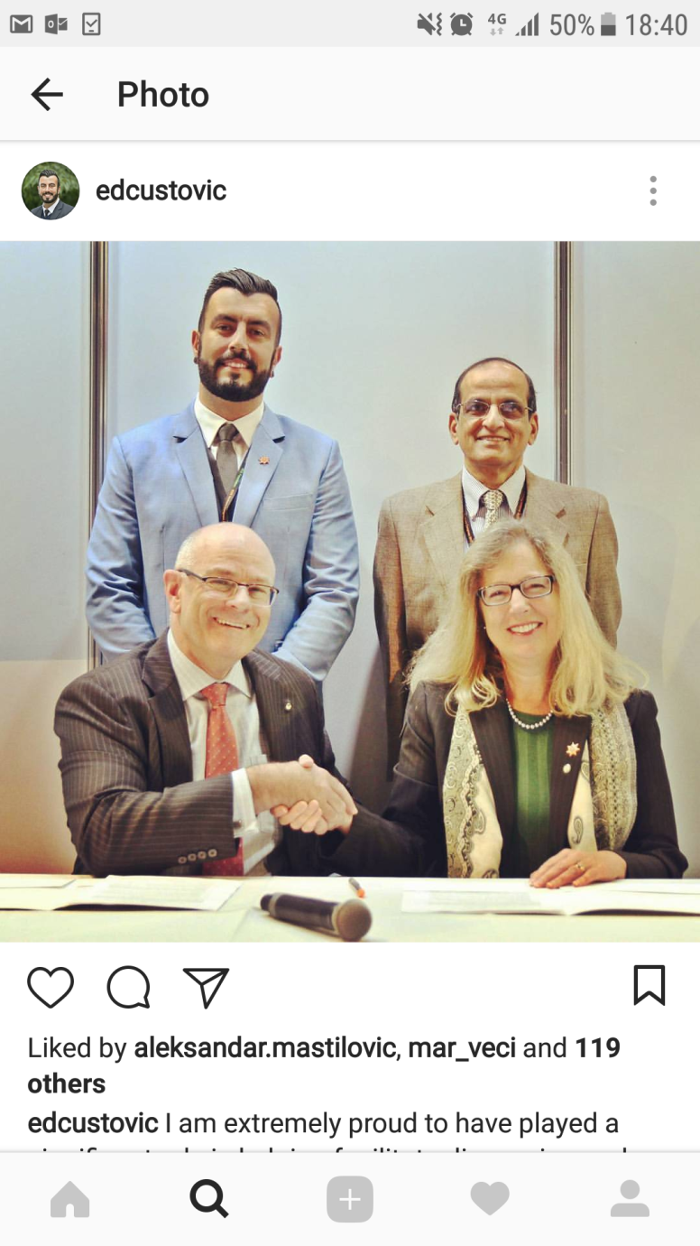
CEO IEEE Karen Bartleson signing agreement with Engineers Australia CEO Peter McIntyre. IEEE Vic/Tas chair Eddie Custovic is behind on the left.

